**CSC 255**

**Computer Network**

**Rutvik ManishKumar Patel**

**Socket Programming Assignment 1 – Email Spoofing**

1. **Screenshot of utput of python code on Athena**

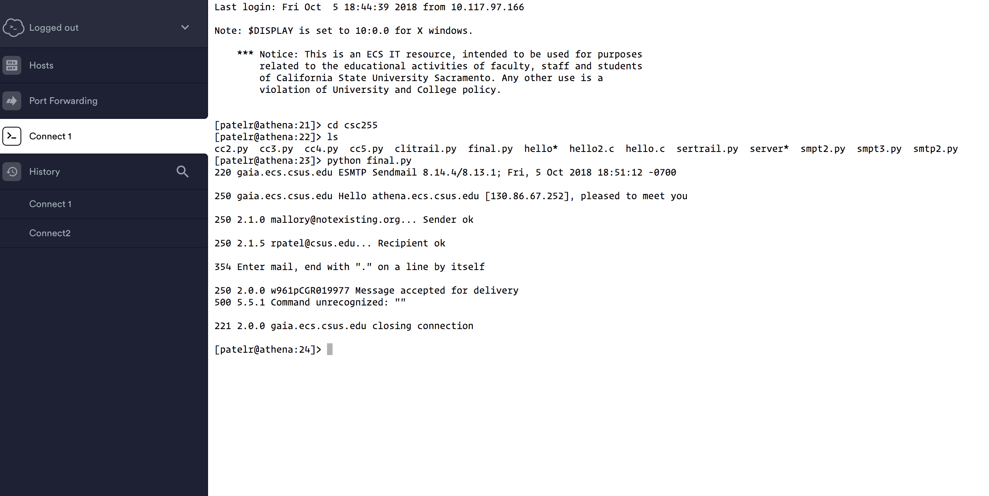

1. **Screenshot of Spoofed Email**

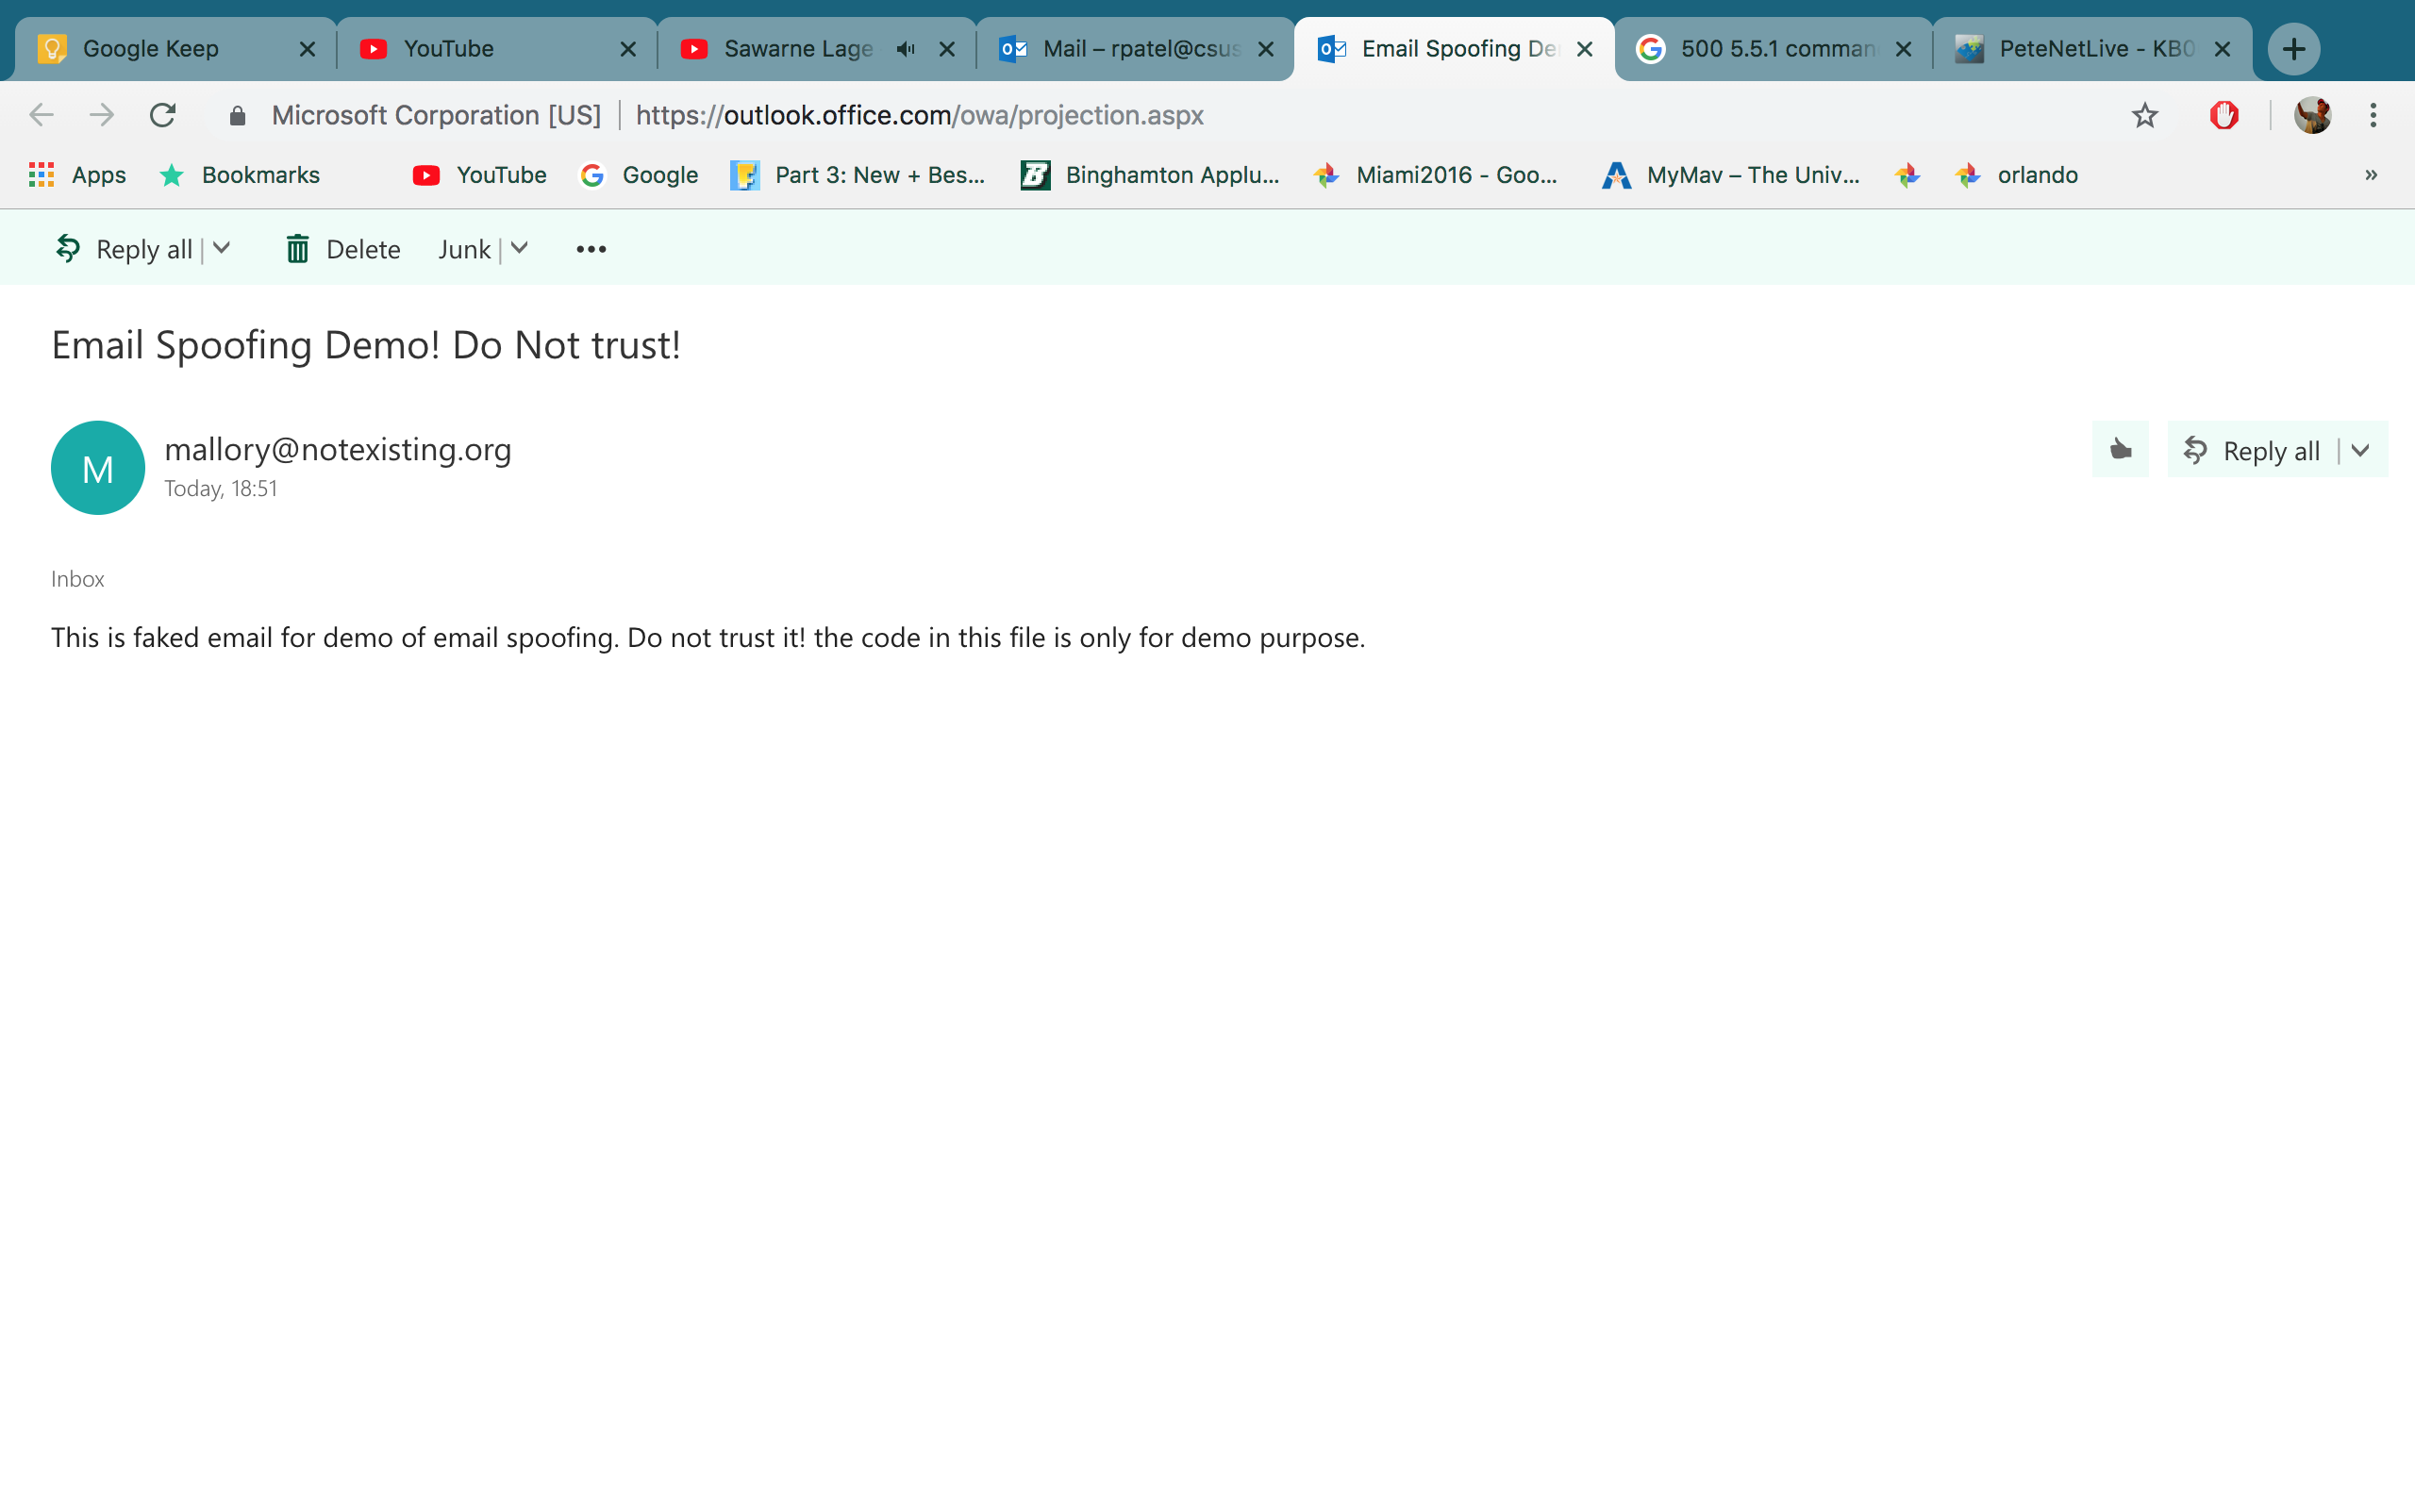

**Python code**

**Final.py**

--------------------------------------------------------------------------------------------------------------------------

from socket import *

heloCommand = 'HELO Rutvik\r\n'

mailserver = 'gaia.ecs.csus.edu'

clientSocket = socket(AF_INET, SOCK_STREAM)

clientSocket.connect((mailserver, 25))

connect = clientSocket.recv(1024)

print connect

if connect[:3] != '220':

print '220 reply not received from server.'

#Sending First HELO"

clientSocket.send(heloCommand)

recvhelo = clientSocket.recv(1024)

print recvhelo

if recvhelo[:3] != '250':

print '250 reply not received from server.'

clientSocket.send("MAIL From: mallory@notexisting.org\r\n")

recv = clientSocket.recv(1024)

print recv

if recv[:3] != '250':

print '250 reply not received from server.'

clientSocket.send("RCPT TO: rpatel@csus.edu\r\n")

recv2 = clientSocket.recv(1024)

print recv2

if recv2[:3] != '250':

print '250 reply not received from server.'

clientSocket.send("DATA\r\n")

recv3 = clientSocket.recv(1024)

print recv3

if recv3[:3] != '354':

print '354 reply not received from server.'

clientSocket.send("SUBJECT: Email Spoofing Demo! Do Not trust!\nThis is faked email for demo of email spoofing. Do not trust it! the code in this file is only for demo purpose. \n.\n\r\n")

recv4 = clientSocket.recv(1024)

print recv4

if recv4[:3] != '250':

print '250 reply not received from server.'

clientSocket.send("QUIT\r\n")

recv5 = clientSocket.recv(1024)

print recv5

if recv5[:3] != '221':

print '221 reply not received from server.'